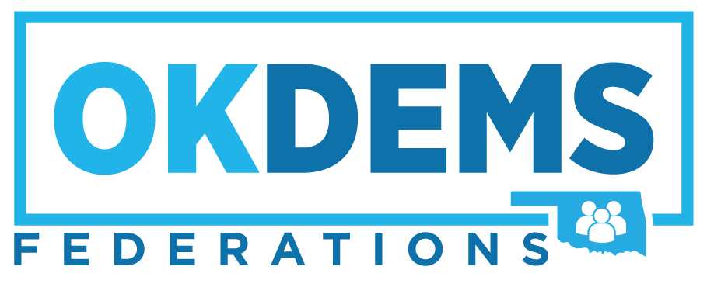

Oklahoma Federation of Democratic Women
Date: June 3, 2023
Room: Equity
Time: 11:45 am
- Call to Order, Welcome and Introductions
Dr. Bettye Rector, President

- Pledge of Allegiance
Marion Hill, Second Vice President

- Land Acknowledgement Statement
Jana Lewis-Harkins, Immediate Past President

- Special Music
“This Land is My Land, This Land is Your Land”

- NFDWC Report
Debi Thompson, NFDWC 4th Vice President

- Treasurer’s Report
Karen Gaddis, Treasurer

- Program: “ Equal Rights Amendment Centennial Campaign “
Introduction by Debbie Hogue-Downing , NFDW ERA Legislative Sub-Committee

- Special Presentation by “Alice Paul, Susan B. Anthony, Elizbeth Cady Stanton, and Ida B. Wells”

- Adjourn
Put Women in the Constitution!
We’ve Waited Long Enough!

